38.18: Lyman: largest is 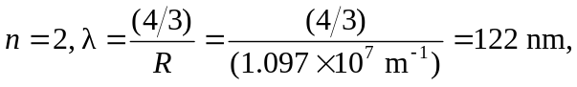in the ultraviolet. Smallest is 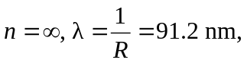 also ultraviolet. Paschen: largest is 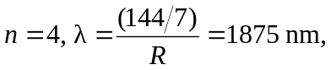in the infrared. Smallest is 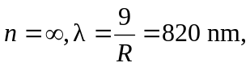also infrared.

